Here Main_output is output file generate by my compiler and Main is the file which TextComparer compares it to.

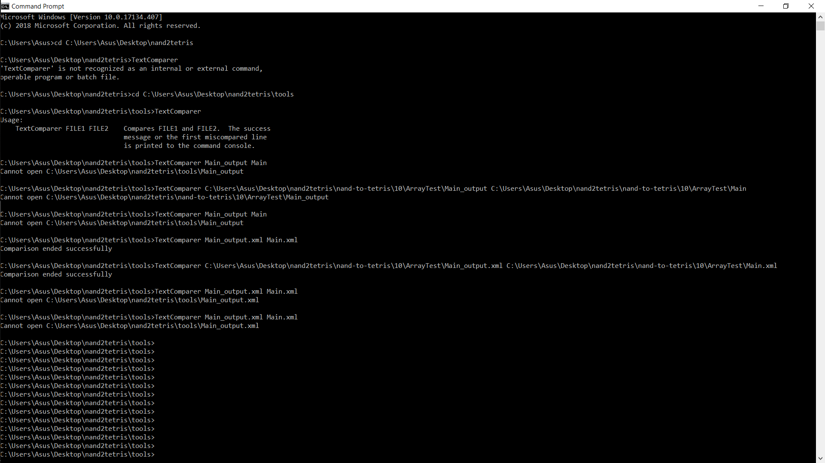

Change the directory to same as TextComparer

Bring the files to be compared in the same directory as TextComparer and then run: TextComparer (file1.extension) (file2.extension)

OR

Bring the files to be compared in the same directory as TextComparer and then run: TextComparer (location of directory/ location of file1.extension) (location of directory/ location of file2.extension)

Both of the above two methods has been applied in the picture given above.